Foundations of Multiplication and Division
3.OA Conceptual Understanding Mini-Assessment by Students Achievement Partners

OVERVIEW
This mini-assessment is designed to illustrate assessment of early progress in the 3.OA domain. This mini-assessment is designed for teachers to use either in the classroom, for self-learning, or in professional development settings to:
- Evaluate students’ understanding of aspects of 3.OA addressed early in the learning of multiplication and division in order to prepare to teach this material or to check for student understanding, and to check for student progress toward fluency;
- Gain knowledge about assessing some of the conceptual understanding, procedural skills, fluencies, and applications of multiplication and division;
- Illustrate CCR-aligned assessment problems;
- Illustrate best practices for writing tasks that allow access for all learners; and
- Support mathematical language acquisition by offering specific guidance.
MAKING THE SHIFTS
This mini-assessment attends to focus as it addresses the earliest understandings of multiplication and division, which are at the heart of the grade 3 standards and a key component of the Major Work of the Grade. This mini-assessment addresses only some of the third-grade expectations for multiplication and division. Later in grade 3, students will use this foundational understanding of multiplication and division to coherently progress to fluency with all single-digit products and real-world applications involving area and measurement. The full 3.OA domain sets an expectation for students to understand the concepts of multiplication and division (conceptual understanding), be fluent in procedures of multiplying and dividing (procedural skill/fluency), and be able to solve word problems using multiplication and division and eventually all 4 operations (application). Therefore, this mini-assessment has components of all three of these aspects of rigor so that students can work toward full expression of these skills and concepts.
A CLOSER LOOK
3.OA.A Represent and solve problems involving multiplication and division.
3.OA.B Understand properties of multiplication and the relationship between multiplication and division.
3.OA.C Multiply and divide within 100.
This mini-assessment of early multiplication and division focuses largely on conceptual understanding. Specifically, grade 3 students know that the product a × b means the number of things in a groups of b objects each. Some conceptual questions on the mini-assessment are brief checks, while others require students to share their mathematical reasoning.
Knowing the multiplication table from memory is expected by year’s end, so this mini-assessment of early progress focuses on fluency with the factors 0, 1, 2, 5, and 10. Students also practice finding products for the other factors so they can build toward fluency over the school year. Finally, situations of equal groups are ubiquitous in real life; the mini-assessment includes some word problems that allow students to apply multiplication and division skills.
There are more problems on this mini-assessment than should be given to students during a typical class period. Therefore, the assessment can be administered over more than one day or only selected problems used based on the particular local context.

CONNECTING THE STANDARDS FOR MATHEMATICAL PRACTICE TO GRADE-LEVEL CONTENT
The Operations and Algebraic Thinking domain requires meaningful connections to several standards for mathematical practice. In questions #8 and #13, students must analyze a situation and make a conjecture. The conjecture must then be supported by evidence, whether in the form of examples or an explanation. Through this process, students are constructing viable arguments and critiquing the reasoning of others (MP3). Problems #4, #11, and #12 show grade-appropriate modeling (MP4). The problems require students to create equations that represent the context and to use visual models to abstract the mathematical elements of the situation.
SAMPLE ADMINISTRATION INSTRUCTIONS FOR FLUENCY SECTION
Sample instructions are given below for the first section of the mini-assessment on fluency:
You will have 2 minutes to answer as many of these questions as you can in pencil. After I call 2 minutes, switch to pen to complete the rest of the fluency problems. You may do the problems in any order you choose.
After completing the fluency section, you may switch back to pencil to complete the assessment.
SUPPORT FOR ENGLISH LANGUAGE LEARNERS
This lesson was designed to include specific features that support access for all students and align to best practice for English Language Learner (ELL) instruction and assessment. Go here to learn more about the research behind these supports. Features that support access in this mini-assessment include:
- Tasks that allow for multi-modal representations, which can deepen understanding of the mathematics and make it easier for students, especially ELLs, to give mathematical explanations.
- Tasks that avoid unnecessarily complex language to allow students, especially ELLs, to access and demonstrate what they know about the mathematics of the assessment.
Prior to this mini-assessment, ensure students have had ample opportunities in instruction to read, write, speak, listen for, and understand the mathematical concepts that are represented by the following terms and concepts:
- equal groups
- equation
Students should engage with these terms and concepts in the context of mathematical learning, not as a separate vocabulary study. Students should have access to multi-modal representations of these terms and concepts, including: pictures, diagrams, written explanations, gestures, and sharing of non-examples. These representations will encourage precise language, while prioritizing students’ articulation of concepts. These terms and concepts should be reinforced in teacher instruction, classroom discussion, and student work (for example, through engagement in mathematical routines).
ELLs may need support with the following words found in this mini-assessment:
- determine
- decide
- circle
- explain
- describe
- altogether
- diagram
- neither
- both
- arrangement
- situation
In preparation for giving this mini-assessment, teachers should strive to use these words in context so they become familiar to students. It will be important to offer synonyms, rephrasing, visual cues, and modeling of what these words mean in the specific contexts represented in the items in this mini-assessment. Additionally, teachers may offer students the use of a student-friendly dictionary, or visual glossary (example below) to ensure they understand what is being asked of them in each item.
Sketch | 
Point | •
Locate | •
An example of a visual glossary for student use
Name: Date:
Section 1: Fact Fluency
2 × 2 = _____ | 1 × 10 = _____
3 × 10 = _____ | 8 × 2 = _____
5 × 1 = _____ | 0 × 3 = _____
5 × 5 = _____ | 7 × 10 = _____
8 × 5 = _____ | 5 × 6 = _____
_____ = 5 × 3 | _____ × 2 = 10
3 × _____ = 6 | 8 × _____ = 0
_____ × 10 = 50 | _____ × 4 = 40
7 × 5 = _____ | _____ × 2 = 8
2 × _____ = 12 | _____ × 1 = 9
_____ = 8 × 1 | _____ × 5 = 20
1 × _____ = 6 | 9 × _____ = 45
_____ × 10 = 0 | _____ × 9 = 18
7 × _____ = 7 | _____ × 2 = 20
2 × _____ = 14 | _____ = 10 × 10

Section 2: Answer all 12 questions.
- Circle each picture that shows equal groups.
Picture 1  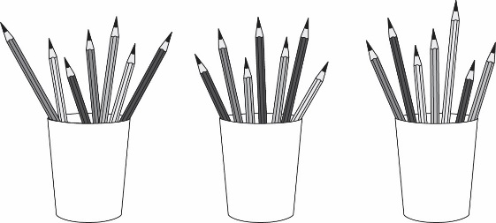 | Picture 2  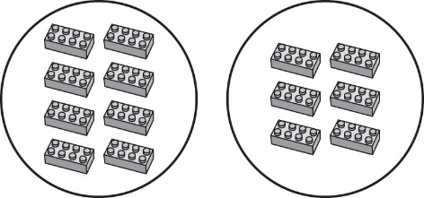
Picture 3  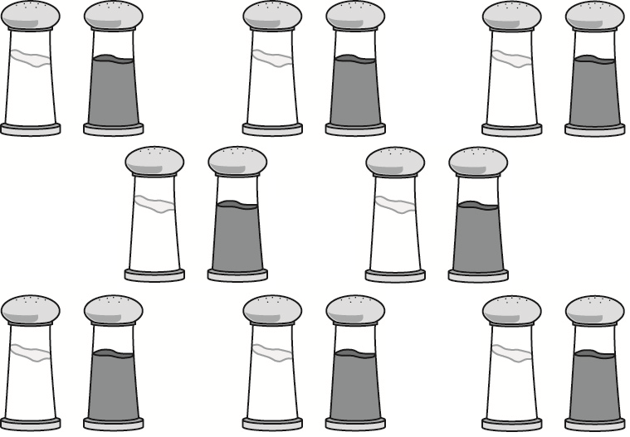 | Picture 4  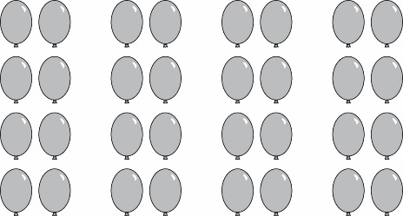

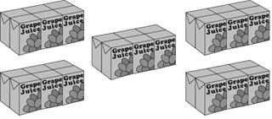
- Packs of juice boxes are shown below.

- How many equal packs are there?
How many juice boxes are in each pack?
What is the total number of juice boxes?
- Write an equation that represents the arrangement of juice boxes.
× =

  - There are 5 bowls with 4 grapes in each bowl. Write an equation that represents the arrangement of grapes.
× =

  - How many grapes are there altogether?

grapes altogether

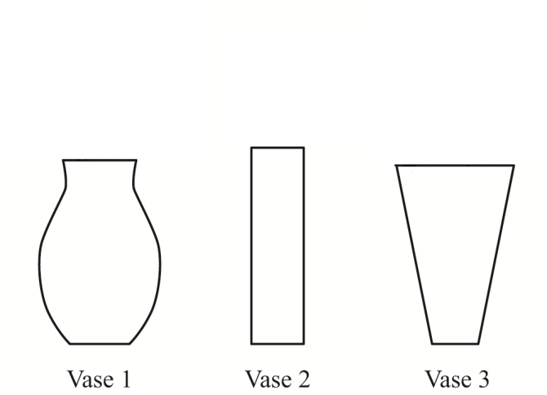
- Parker’s Flowers New Flower Arrangement
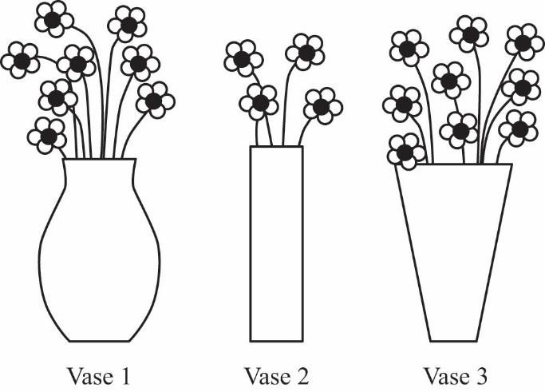
- Rearrange the flowers in Parker’s vases so each vase has the same number of flowers. Draw the new flower arrangement.

- Write an equation to represent the new flower arrangement.
× =

- Mrs. Oro needs to buy 90 corn seeds. The Garden Center sells corn seeds in packs of 10 seeds each.
  - Write a division equation showing how many packs of seeds Mrs. Oro should buy.
$÷$ =

  - Write a multiplication equation showing how many packs of seeds Mrs. Oro should buy.

× =

- What is the unknown number that makes each equation true?
21 ÷ 7 =  = | × 6 = 36  =
6 × □ = 24  □ = | H ÷ 3 = 4  H =

- Ken says that every time you multiply two numbers, the product is greater than each of the factors.

Decide whether Ken is correct or incorrect. Explain your answer using number and/or words.

- In which situation is the number of plums equal to 58 × 29?
- Sam buys 58 plums and puts 29 plums in each of 2 bags.
- Ron buys 58 bags with 29 plums in each bag.
- Tim buys 58 plums and gives 29 of the plums away.
- Dan has 58 plums and buys 29 more plums.

- Mrs. Ling puts 30 students in teams of 5 students each.
  - Draw a diagram that shows how Mrs. Ling arranged the students.
  - The equation 30 $÷$5=6 represents the arrangement of students. Explain what the 6 represents in the equation.

- Mrs. Shapiro has 28 markers. She has red, blue, yellow, and black markers. She has the same number of markers in each color.
  - How many markers in each color does Mrs. Shapiro have?
  - Explain your answer using numbers, words, and/or pictures.
- Amy and Bonnie have 100 stickers. They are putting an equal number of the stickers into 5 sticker books.
Amy wrote the following division equation to determine the number of stickers to put in each sticker book:
100 $÷$5 = ____
$$Bonnie$$wrote the following multiplication equation to determine the number of stickers to put in each sticker book:
5 x ____ = 100

a. Who is correct? Circle one answer.
Neither person Amy Bonnie Both people
b. Explain your answer using numbers, words, and/or pictures.

12. Describe a situation that could be represented by the equation 10 ÷ 1 = 10.

Timing: Overall, this assessment (both sections 1 and 2) is intended to take about 35–40 minutes.
Section 1 Instructions:
You will have 2 minutes to answer as many of these questions as you can in pencil. After I call 2 minutes, switch to pen to complete the rest of the fluency problems. You may do the problems in any order you choose.
After completing the fluency section, you may switch back to pencil to complete the assessment.
Use the answers to the fluency section to guide fluency instruction in future work on multiplication.
Students are not expected to complete all 30 problems in 2 minutes at this time. Students should progress throughout the year with their fluency of one-digit multiplication facts.
Section 1 Answer Key.
2 × 2 = __4__ | 1 × 10 = __10__
3 × 10 = __30__ | 8 × 2 = __16__
5 × 1 = __5__ | 0 × 3 = __0__
5 × 5 = __25__ | 7 × 10 = __70__
8 × 5 = __40__ | 5 × 6 = __30__
__15__ = 5 × 3 | __5__ × 2 = 10
3 × __2__ = 6 | 8 × __0__ = 0
__5__ × 10 = 50 | __10__ × 4 = 40
7 × 5 = __35__ | __4__ × 2 = 8
2 × __6__ = 12 | __9__ × 1 = 9
__8__ = 8 × 1 | __4__ × 5 = 20
1 × __6__ = 6 | 9 × __5__ = 45
__0__ × 10 = 0 | __2__ × 9 = 18
7 × __1__ = 7 | __10__ × 2 = 20
2 × __7__ = 14 | __100__ = 10 × 10

Section 2 Instructions: As students complete Section 1, they can move to Section 2.

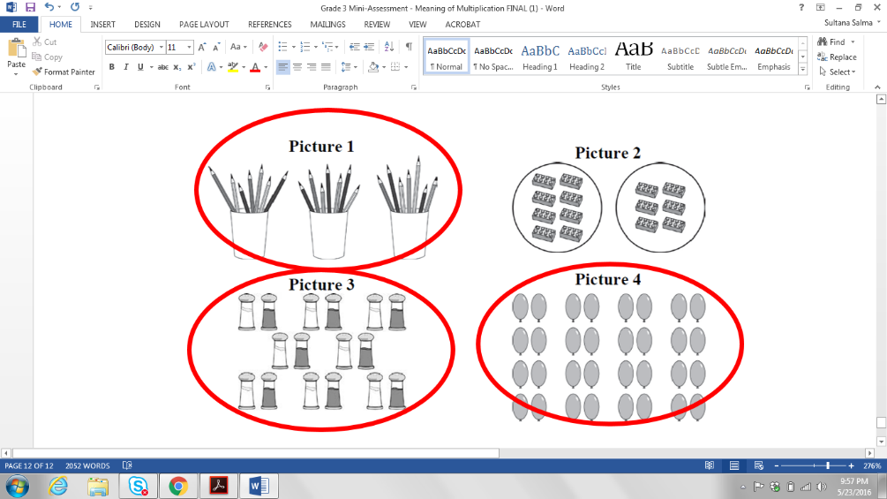
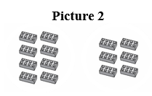
Section 2 Answer Key.

- Note: Students should recognize the cups of pencils as equal groups, even though there are pencils of different colors and lengths.

  - 5 equal packs
6 in each pack
30 total
  - 5 × 6 = 30, or equivalent
Note: Students should not receive credit for equations using repeated addition since this application involves groups of objects which is a multiplication situation.

- 5 × 4 = 20
20 grapes altogether

  - Each vase should have 7 flowers.
  - 3 × 7 = 21
Note: Students should not receive credit for equations using repeated addition since this application involves groups of objects which is a multiplication situation.

  - 90 ÷ 9 = 10 (preferred); 90 ÷ 10 = _; 90 ÷ _ = 10; OR 90 ÷ 10 = 9

  - Correct equations include: 9 × 10 = 90 (preferred); _ × 10 = 90; 10 × _ = 90; OR 10 × 9 = 90

Note: Students may write equations with only numbers or may incorporate variables. Both types of responses should receive full credit as indicated.

= 3 | = 6
□ = 4 | H = 12

- Student states that Ken is incorrect and provides a counterexample or sufficient reasoning to support their decision.

Sample answer:

Ken is incorrect. When a number is multiplied by 1 or 0, for example, the product is not greater than the factors. One example is 3 x 0 = 0. The product, 0, is equal to but not greater than the factor 0 and less than the factor 3.

- b. Ron buys 58 bags with 29 plums in each bag.

  - Sample diagram:
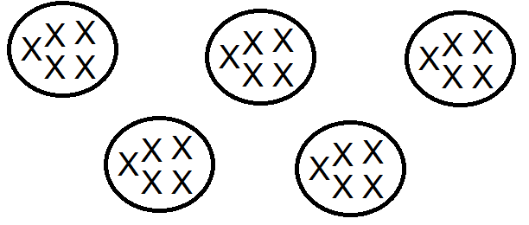
  - The student states that the 6 in the equation represents the number of groups of students.

  - 7
  - Adequate work can include words, equations, or visual models detailing 28 ÷ 4 = 7

  - “Both people”
  - An explanation of division as the inverse of multiplication (e.g., “I know the solution to
100 ÷ 5 = ? is the same as ? × 5 = 100.”)
- Any situation that entails dividing 10 things into 1 group of 10

For more on the Major Work of the Grade, see achievethecore.org/focus.

